PROJECT PLAN — Django News Application
1. Project Overview
The goal is to build a full‑stack news publishing platform where:

- Journalists create articles & newsletters

- Editors approve, update, and delete content

- Readers view content and subscribe to journalists/publishers

- A REST API exposes approved content

- Signals or view logic triggers email + X (Twitter) posting on approval

- The system uses MariaDB, custom user roles, and token authentication

2. Functional Requirements
User Roles
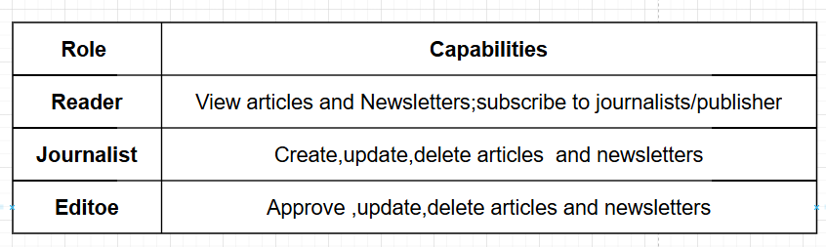
Core Features
Articles
- Title, content, author, created_at, approved, publisher

- Article belongs to either:

- A journalist (independent)

- A publisher (publisher content)

- Editors approve articles

Publishers
- Has multiple editors & journalists

Newsletters
- Created by journalists

- Many‑to‑many relationship with Articles

- Viewable by readers

Custom User Model
- Role field (Reader, Journalist, Editor)

- Group assignment based on role

- Reader fields:

- subscriptions to publishers (M2M)

- subscriptions to journalists (M2M)

- Journalist fields:

- independent articles (reverse FK)

- independent newsletters (reverse FK)

- If role = Journalist → reader fields = None

- If role = Reader → journalist fields = None

Article Approval Logic
Choose one:

Option 1 — Django Signals
- post_save signal triggers when approved=True

- Sends email to subscribers

- Makes POST request to X (Twitter)

Option 2 — View Logic
- Approval view handles:

- Email sending

- X posting

(Next Page )

REST API Requirements
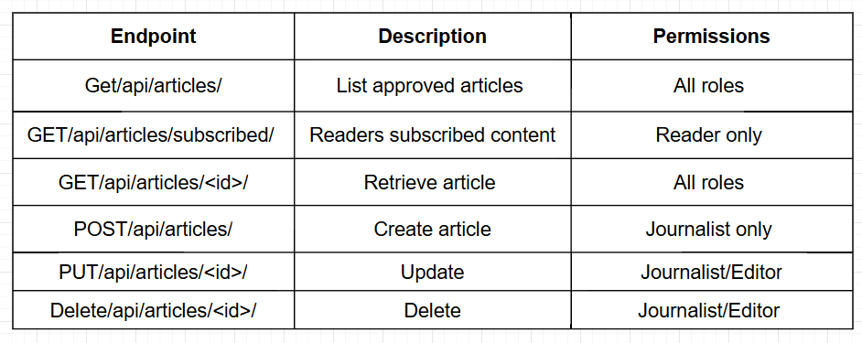

Authentication
Token-based (JWT or DRF TokenAuth)

Authorization
Role-based permissions using Django Groups

(Next Page )
3. Non‑Functional Requirements
- Security: Role-based access control, token auth

- Performance: Efficient queries, prefetch_related

- Scalability: Normalized DB, modular architecture

- Maintainability: PEP8, comments, modular functions

- Reliability: Unit tests for API + signals

- UX/UI: Clean templates, intuitive navigation

4. System Architecture
Architecture Style
- Django MVC (Model–View–Template)

- Django REST Framework for API

- MariaDB as relational database

- Signals or view logic for async tasks

High-Level Diagram
User → Django Views → Templates
User → DRF API → Serializers → Models → MariaDB
Editor Approval → Signal/View Logic → Email + X API

5. Database Design
Entities
User (CustomUser)
- id

- username

- email

- password

- role (choices: Reader, Journalist, Editor)

- subscriptions_publisher (M2M)

- subscriptions_journalist (M2M)

Publisher
- id

- name

- editors (M2M to User)

- journalists (M2M to User)

Article
- id

- title

- content

- author (FK to User)

- publisher (FK to Publisher, null=True)

- approved (Boolean)

- created_at (DateTime)
Newsletter
- id

- title

- description

- author (FK to User)

- created_at

- articles (M2M to Article)

6. User Interface Planning (UI/UX)
Pages
- Home page (list approved articles)

- Login/Register

- Reader dashboard (subscriptions)

- Journalist dashboard (create/edit articles)

- Editor dashboard (approve articles)

- Newsletter pages

- Article detail page

UX Considerations
- Clear navigation based on role

- Buttons disabled for unauthorized actions

- Clean typography and spacing

- Error messages for invalid input

7. Access Control Strategy
Groups
- ReaderGroup

- JournalistGroup

- EditorGroup

Permissions
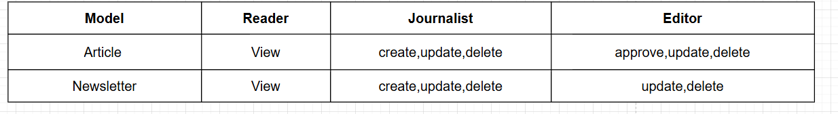

Middleware / Decorators
- @permission_required

- @login_required

- Custom role-check decorators
8. API Design (Detailed)
Serializers
- ArticleSerializer

- PublisherSerializer

- NewsletterSerializer

- UserSerializer

(Next page )

Views
- Class-based views (APIView or ViewSets)

- Token authentication

- Permission classes:

- IsAuthenticated

- IsJournalist

- IsEditor

- IsReader

(Next page )

9. Testing Plan
Unit Tests
Use Django TestCase + APIClient.

Test Categories
1.Authentication

- Token generation

- Role-based access

2.Reader Tests

- Can view articles

- Can only view subscribed content

3.Journalist Tests

- Can create articles

- Cannot approve

4.Editor Tests

- Can approve articles

- Can delete articles

5.Newsletter Tests

- Creation, update, retrieval

6.Signal Logic

- Mock email sending

- Mock X API POST request

7.Failure Cases

- Unauthorized access

- Invalid data

- Missing fields
10. Deployment & Database Migration
MariaDB Setup
- Update DATABASES in settings.py

- Install mysqlclient

- Run migrations

Deployment Considerations
- Use environment variables for secrets

- Configure email backend

- Configure X API credentials

